Assessment Task for Reading
Topic: Applying for a Job
This assessment task focuses on developing senior secondary students’ reading skills.
This set of materials contains the following:
- 4 reading texts
- 4 set of questions
- Suggested answers

Reading Text
Text 1: A job advertisement
Telemarketer wanted
Blomfeld Consulting Ltd. is looking for a self-motivated, outgoing and result-driven young telephone salesperson, with Secondary 6 education or above, to handle outbound calls to existing and potential clients and develop a new customer database to maximize business growth and reach assigned targets.
Job requirements:
- effective communication and interpersonal skills
- strong analytical skills
- fluency in Cantonese
- good command of English and Mandarin
- experience in telemarketing an advantage
We offer an attractive basic salary, which you will supplement with commissions, on-the-job training, stable working hours and 12-day annual leave per year.
Please send your application with a full resume, the names and contact details of two referees and your expected salary to Mr Jeremy Fong, Recruitment Manager, Blomfeld Consulting Ltd., PO Box 493, Sham Shui Po, Kowloon, by 16 April 20XX.
Text 2: Erica’s application letter
Room 24D, Block 2
Bellevue Mansion
North Point
Hong Kong

14 April 20XX

Mr Jeremy Fong
Recruitment Manager
Blomfeld Consulting Ltd.
PO Box 493
Sham Shui Po
Kowloon

Dear Mr Fong

Application for the Post of Telemarketer
I am writing to apply for the post of Telemarketer, which was advertised in Friends magazine on 10 April 20XX.
I am self-motivated and outgoing. I am fluent in Cantonese and speak good English and Mandarin.
Currently I am studying for Hong Kong Diploma of Secondary Education Examination and will complete my Secondary Education in May 20XX.
Since I was in Secondary 2, I have been on the editorial committee of the school newspaper. In this period, I have developed excellent communication, analytical and collaborative skills.
Working for Blomfeld Consulting Ltd. appeals to me because of its good reputation, high-quality services and training to its employees. I believe I can contribute to your organization with communication, analytical and collaborative skills.
I am available for an interview at any time. I can be contacted most easily on 9876 5432 or via erica588@hkinternet.com.hk. I look forward to meeting you.

Yours sincerely
Erica Tse
Tse Mei Ling, Erica
Encl: Resume

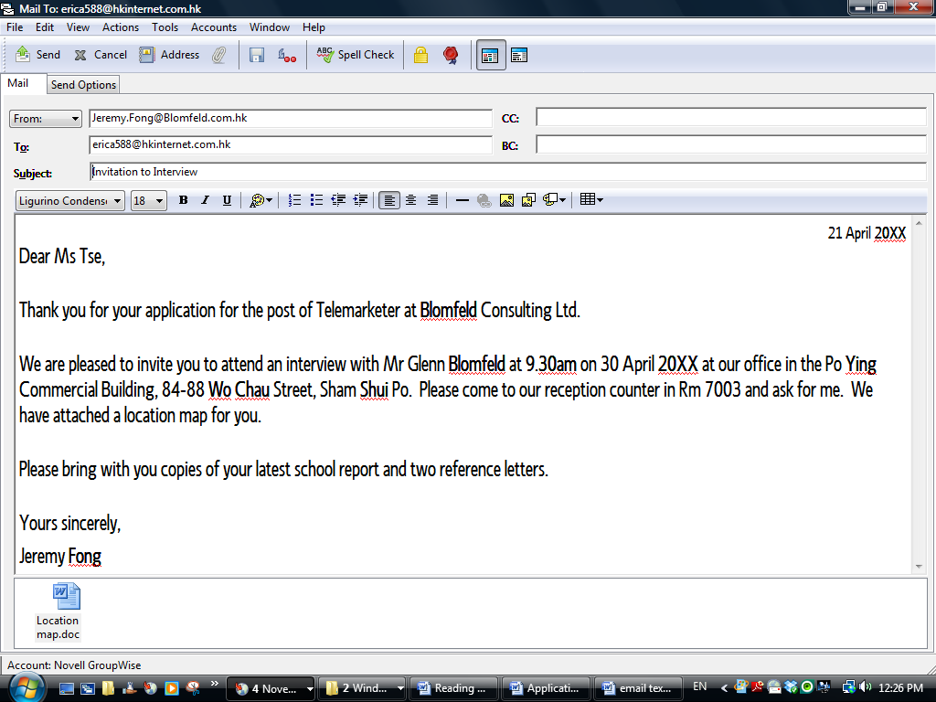
Text 3: Invitation to attend an interview
Text 4: One of Erica’s reference letters
To whom it may concern:
I have had the pleasure being Erica TSE’s form teacher for the last 3 years. After these three years, she has matured into a responsible and likeable young woman.
Erica is sociable, caring and helpful. In class, she gets on well with students and always shows care and offers help to both teachers and students. Out of the classroom, she is involved in the school’s Befrienders programme, helping new immigrant students to settle into the school.
Erica is also very organised and helps with class administration tasks. She has been responsible for our form room newsboard, keeping the announcements up-to-date.
I have no hesitation in recommending her to you.
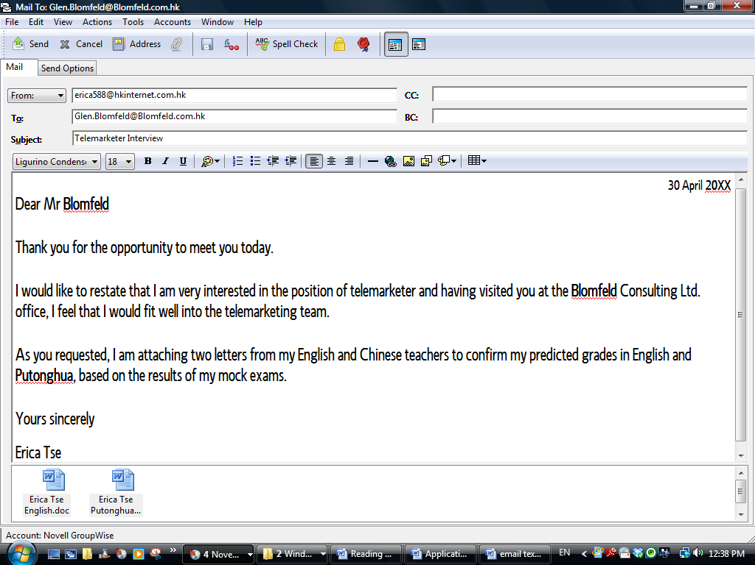
Text 5: Erica’s follow-up email
Text 6: Erica’s offer of employment

Confidential
Ref TM0512

24 May 20XX

Room 24D, Block 2
Bellevue Mansion
North Point
Hong Kong
LETTER OF APPOINTMENT

Dear Ms Tse

I am pleased to offer you a position as a Telemarketer at Blomfeld Consulting Ltd. on the terms set out in the attached terms.

To accept this appointment, please sign one copy of this Letter of Appointment, and return it to us by 15 June.

I look forward to welcoming you to the Blomfeld Consulting Ltd. team.

Yours sincerely

Mabel Chan

Mabel Chan
for Jeremy Fong

-Page 1 of 2-
PO Box 493, Sham Shui Po, Kowloon
Blomfeld Consulting Ltd.

TERMS
Post: Telemarketer
Commencement of employment: 15 July 20XX
Working schedule: Monday-Friday
Remuneration: HK$ 8,200 per month, plus sales commission
Salary
Your remuneration will be subject to review annually and adjustments will be determined by the company after taking into consideration such factors as your performance, market trend and company performance, and any other factors considered appropriate. Any adjustment of your rate of remuneration will be communicated to you in writing.
Duties
Your job duties include:
- making calls to existing clients
- calling potential clients
- developing a new customer database
- achieving your assigned monthly target
- any tasks assigned by the Marketing Manager
Leave
You will be entitled to all public holidays and upon completion of not less than 2 months’ continuous service, you will be entitled paid annual leave accrued at a rate of one day per month up to a maximum of 12 days, and 4 day paid sick leave per year.
Benefits
You will enjoy Class C medical benefits as laid out in the BAPU medical scheme enclosed.
Termination of appointment
Your appointment may be terminated by either party at any time by giving to the other party a 2-week written notice.
MPF
You shall be a basic member of Blomfeld Consulting Ltd.’s MPF scheme. Blomfeld Consulting Ltd. will contribute to the scheme at the rate specified by the appropriate legislation and you are also required to contribute at the specified rate.
Confidentiality
You shall not at any time during or after the termination of your employment under this appointment, make use of, divulge or communicate to any person any confidential information relating to Blomfeld Consulting Ltd. which may have come to your knowledge in the course of your employment.

I accept this offer of appointment and agree to the terms of this letter:
Signed:
Name:
Date:
-Page 2 of 2-

END OF READINGTEXTS
Questions
Read the Text 1- 6 and answer questions 1-13. Blacken the circle when appropriate.
- According to Text 1, what are the 2 main job duties of a telemarketer? (2 marks)

- _______________________________________________________________

- _______________________________________________________________

- Find phrases in Text 1 which mean the same as the following: (4 marks)
possible customers
an ability to communicate effectively in (English and Mandarin)
regular work schedule
wage you would like to receive
- According to Text 1, fill in the column “Skills & qualities required” below with the skills & qualities required for a telemarketer. Based on Text 2, put a “√” next to each skill or quality Erica has and put a “x” next to that she does not. (9 marks)

Skills and qualities required | Erica
Self-motivated
Result-driven

- Give two reasons why Erica wants to work for Blomfeld Consulting Ltd. (2 marks)
_____________________________________________________________________
_____________________________________________________________________
_____________________________________________________________________
5. Complete Erica’s schedule with details of the interview. (4 marks)
30 April

Interview @ Blomfeld Consulting Ltd.
Location:

Ask for:
Location map link
Meet Cindy for lunch
Location: Tasty Inn

12.00

6. Read the reference letter from Erica’s form teacher. Which two tenses did her form teacher use in the reference letter? Why? (3 marks)
_____________________________________________________________________
_____________________________________________________________________
_____________________________________________________________________

7. Erica took two reference letters to the interview. One was from her form Teacher (Text 4). Which teacher may have written the other reference letter (which is not included here) for her? Justify your answer with information from the reading texts. (2 marks)
_____________________________________________________________________
_____________________________________________________________________
_____________________________________________________________________

8. During the interview, Mr Blomfeld asked Erica about the Befrienders programme. Give one skill/ quality Erica’s experience with the programme demonstrates. (2 marks)
_____________________________________________________________________
_____________________________________________________________________
_____________________________________________________________________

9. Why did Erica write to Mr Blomfeld after the interview? (2 marks)
_____________________________________________________________________
_____________________________________________________________________
_____________________________________________________________________

10. What will Blomfeld Consulting Ltd. look at when they are considering a pay rise for Erica? (3 marks)
_____________________________________________________________________
_____________________________________________________________________
_____________________________________________________________________
11. Who will Erica’s immediate boss be? (1 mark)
_____________________________________________________________________
12. If Erica wants to take a new job starting on Monday 28 March, when must she give notice to Blomfeld Consulting Ltd.? (Hint: think about which date her last day of service is) (1 mark)
_____________________________________________________________________

13. If Erica starts work on the date in the contract, when will she be able to take 4 days off to go on holiday with her parents? (1 mark)
_____________________________________________________________________

END OF QUESTIONS

Suggested Answers
1. | (Text 1: A job advertisement)  i. handle outbound calls (to existing and potential clients) (1 mark)  ii. develop a new customer database (1 mark)
2. | (Text 1: A job advertisement) (1 mark each)  potential clients  a good command of English and Mandarin  stable working hours  expected salary
3. | (Text 1: A job advertisement; Text 2: Erica’s application letter) (1mark for each box)  Skills & qualities required Erica  self-motivated √  out-going √  results-driven X  Form 5 education √  effective communication skills √  interpersonal skills √  strong analytical skills √  fluent Cantonese √  good English √  good Mandarin √  experience in telemarketing X
4. | (Text 2: Erica’ application letter) (Any 2: 1 mark each)  Good reputation  Excellent training  She can contribute to the high-quality services
5. | (Text 3: Invitation to attend an interview)  9.30 (am) (1 mark)  Rm 7003 (1 mark)Po Ying Commercial Building, 84-88 Wo Chau St, Shamshiupo (1 mark)  Jeremy Fong (1 mark)
6. | (Text 4: One of Erica’s reference letters)  present perfect and present simple (1 mark)  Present perfect is used to describe what has happened in the last 3 years / in the time the teacher has been her form teacher (1 mark)  Present simple is used to describe her personality which remain the same now (1 mark)
7. | (Text 2: Erica’s application letter; Text 4: One of Erica’s reference letters; Text 5: Erica’s follow-up email)  The teacher Erica worked with on the school newspaper  or  Eric’s English teacher  or  Erica’s Chinese teacher(1 mark)  Any of the above answers is possible as she would probably want to present some evidence of some job-related skills (e.g. language ability, communication, analytical and interpersonal skills). (1 mark)
8. | (Text 1: A job advertisement; Text 4: One of Erica’s reference letters) (1 mark for skill / quality and 1 mark for justification)  Interpersonal skills – befriending new students  Teamwork – programme involves students and teachers  Out-going – initiating contact with new students  Communication skills – talking to new students and answering questions / addressing their worries  Mandarin proficiency – communicating with immigrant students who are from the Mainland
9. | (Text 5: Erica’s follow-up email)  Send 2 more supporting documents (confirmation of mock exam results in English and Putonghua and predicted grades) (1 mark)  Remind Mr Blomfeld about her / make herself stand out from the other interviewees / thank him for the interview (1 mark)
10. | (Text 6: Erica’s offer of employment)  Any 3 of the following: performance, market trend, company performance, other factors considered appropriate (3 marks)
11. | (Text 6: Erica’s offer of employment)  Marketing Manager (1 mark)
12. | (Text 6: Erica’s offer of employment)  By Friday 11 March (1 mark)
13. | (Text 6: Erica’s offer of employment)  14 November (1 mark)

END OF SUGGESTED ANSWERS

